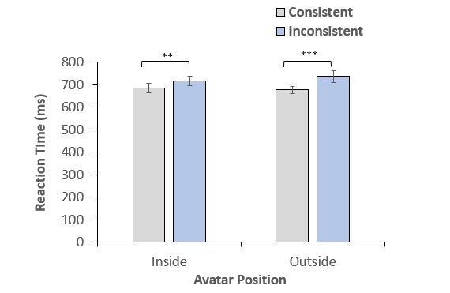

##### Avatar Inside Avatar Outside